Capstone Project:

**Select best strategy for price range in parking meter zone.**

**INTRODUCTION**

Mexican cities experience disorderly and disperse growth alongside insufficient territorial and mobility planning. This has resulted in an urban environment that undermines the quality of life of its inhabitants: road congestion, noise pollution, increase in deaths due to traffic events, loss of productivity, social fragmentation, and an increase of climate change-related emissions due to an excessive use of private motor vehicles are just a few examples of the detrimental effects this causes on society [Parking-Meter-Hipodromo-Mexico-City.pdf. (n.d.). Retrieved from http://mexico.itdp.org/download/19122/]

Playa del Carmen (Spanish pronunciation: ['plaʝa ðel 'kaɾmen]) is a city located along the Caribbean Sea in the municipality of Solidaridad, in the state of Quintana Roo, Mexico. It is a popular tourist area in eastern Mexico. Playa del Carmen features a wide array of tourist activities due to its geographical location in the Riviera Maya. [(n.d.). Retrieved from https://en.wikipedia.org/wiki/Playa_del_Carmen Coordinates (20.6275, -87.0811)]

As a tourist place, Playa del Carmen experiences high parking demand mostly due to an increase in workers who every day occupy on-street parking spaces and use these spaces for parking free of charge and no spaces for tourist people. [Parking-Meter-Hipodromo-Mexico-City.pdf. (n.d.). Retrieved from <http://mexico.itdp.org/download/19122/>]

**PROBLEM**

Government is implementing parking meter as a strategy for mobility and public space as part of sustainable city but we need to know what price range is better for worker, resident and tourist zone.

We want to provide 3 different price range but we need to identify zones.

**DATA**

Parking meter system is a new project, data is only 3 months old, since December to now (history 277544 rows x 29 columns). We are going to analyze and predict price range zones also we have parking meter location data(location).

**DATA CLEANING**

For analysis purpose but I have daily transaction history so I decided to sum each row for having sum and total number of transactions for each parking meter and delete register with 9999 parking meter number. Table 1: shows this new data 196 rows × 4 columns

|  |  |  |  |  |  |  |  |  |  |  |  |  |  |  |  |  |  |  |  |  |  |  |  |  |  |  |  |  |  |  |
| --- | --- | --- | --- | --- | --- | --- | --- | --- | --- | --- | --- | --- | --- | --- | --- | --- | --- | --- | --- | --- | --- | --- | --- | --- | --- | --- | --- | --- | --- | --- |
| | **id** | **Parquimetro** | **total minutos** | **Operaciones** | **Zone** | | --- | --- | --- | --- | --- | | **0** | 10101 | 211601 | 1027 | 1 | | **1** | 10102 | 349932 | 1818 | 1 | | **2** | 10103 | 146668 | 729 | 1 | | **3** | 10104 | 1488209 | 7148 | 1 | | **4** | 10105 | 358109 | 1632 | 1 | |

Table 1 : New data.

Columns ‘*total minutos, operaciones*’ were calculated and with these features I am going to cluster parking zone area.

Let see if there is any relation between these features: fig 1

Fig 1: relation between features.

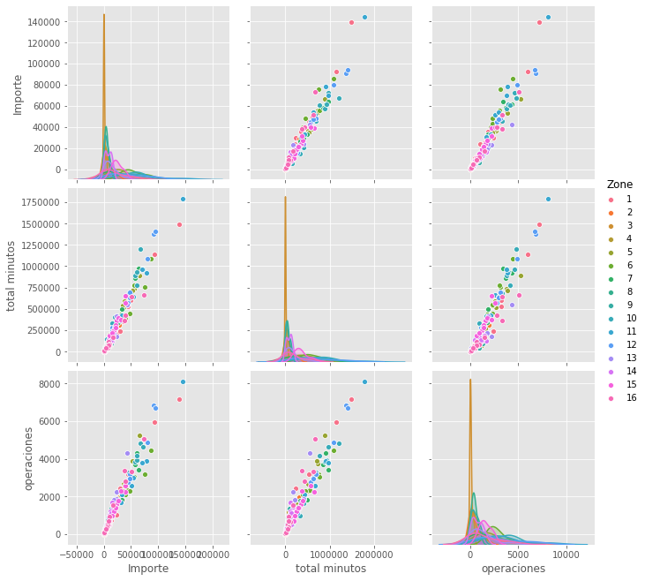

K-Means:

I decided to use K-means to find a relation between parking meters and adjust price is there’s necessary.

Find K value:

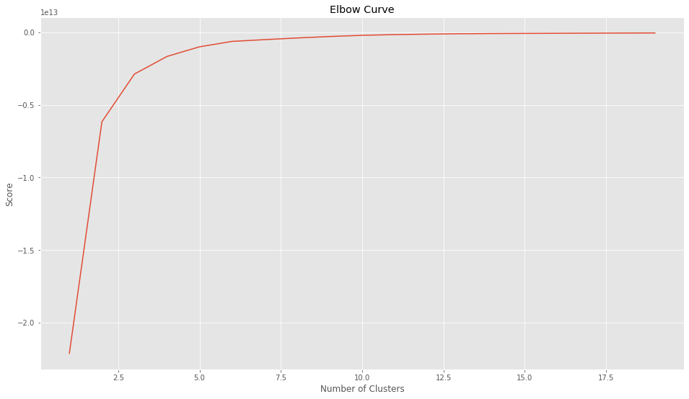

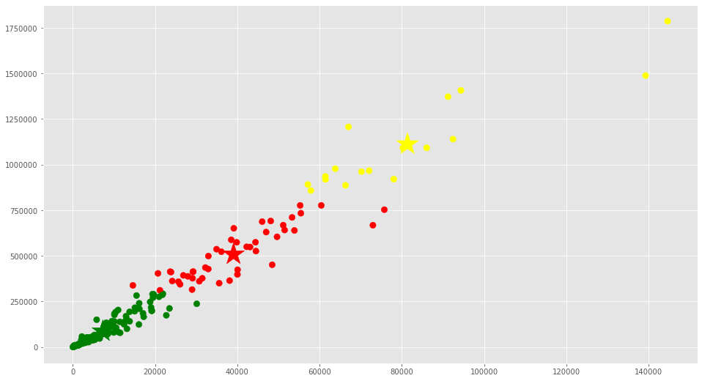 I’ve choose K=3 and is perfect for my project, remember I’m looking to find 3 zones for different prices and after to run kmens, I’ve found the relation between my parking meter.

I’m interested in view how many parking meters for each cluster.

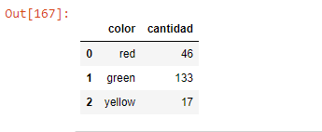

Let’s see how this new clusters are showed on map

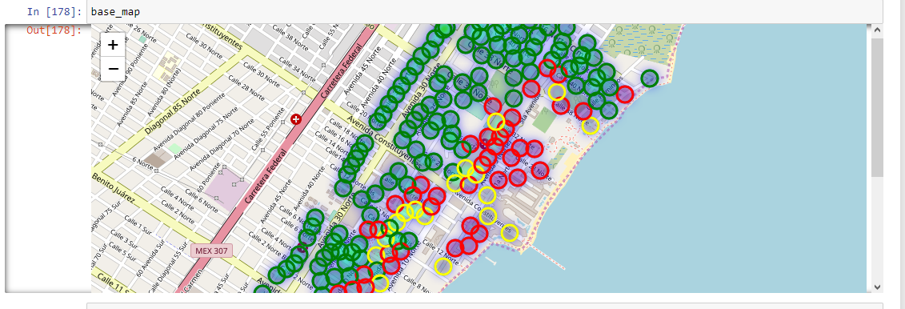

CONCLUSION:

k-means helps me to understand if there’s any relation between parking meter. My first intention was to cluster my parking zone for adjust prices but after to plot my clusters I’ve found there’s some parking meter with less use between 2 parking meters with high use (see figure below)

Figure below shows a green circle is between a red and yellow circle. So, we need to adjust this parking location or inspect if there’s an incident with the parking meter.

